1. SELECT obat.name, obat.symptoms, obat.stock, obat.price, produsen.name FROM obat JOIN produsen ON obat.supplier_id = produsen.id ORDER BY obat.name ASC;

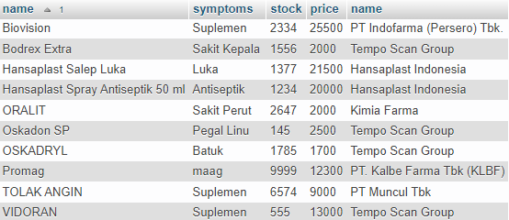

1. SELECT obat.name, obat.symptoms, obat.stock, obat.price, produsen.name FROM obat RIGHT JOIN produsen ON obat.supplier_id = produsen.id ORDER BY obat.name ASC;

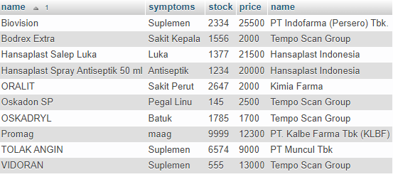

1. SELECT obat.name, obat.symptoms, obat.stock, obat.price, produsen.name FROM obat LEFT JOIN produsen ON obat.supplier_id = produsen.id ORDER BY obat.name ASC;

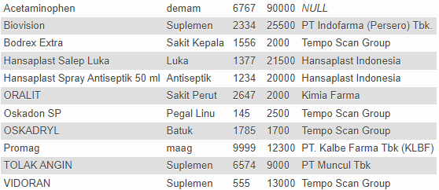

1. SELECT customer.name AS nama, customer.address AS alamat, transactions.amount AS 'jumlah obat' FROM customer JOIN transactions ON customer.id = transactions.cust_id ORDER BY customer.name DESC;

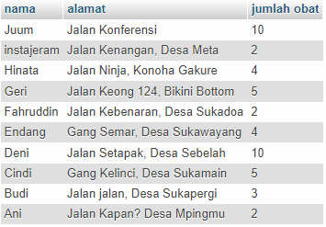

1. SELECT customer.name AS nama, customer.address AS alamat, transactions.amount AS 'jumlah obat' FROM customer JOIN transactions ON customer.id = transactions.cust_id WHERE transactions.amount >=5 ORDER BY transactions.amount DESC;

